HW45 Project Report

Halim Acosta

7/27/2018

Class Design and Testing:

For this project I have designed three classes that work together to form the server and a fourth class for testing the server without using the GUI components that were given as the initial startup code.

The main class that aggregates all the data and handles specifics is the ThreadPool class. This class was designed to maintain a pool of threads that waits on a job queue that services user requests. Each of the main threads also have access to an auxiliary thread pool in case the thread that’s servicing a connection needs more resource use. The ThreadPool class also has a timer object that repeatedly queries the queue for how many jobs are pending as well as querying how many of the threads in the pool are actively servicing a job. The timer object will then perform the necessary actions to regulate the thread usage whether that be to increase the number of threads in the pool or decrease it. The queue is controlled by a Monitor class that controls the access to and from the queue. The queue holds a CustomJob class that carries its input and output streams, the clients id number as well as the service the thread plans to provide. The class comes with different methods for creating Runnables for the different types of commands that server can do. It also comes with an error msg runnable in case there is some kind of error and a toString() method for printing out the job along with its time stamp. The final class that was designed was the ServerTester class which is used to simulate several connections on the server querying different commands. The class supports sending single or multiple commands to the server.

Below is sample output from the tester showing a single user performing each of the supported commands and then killing the server

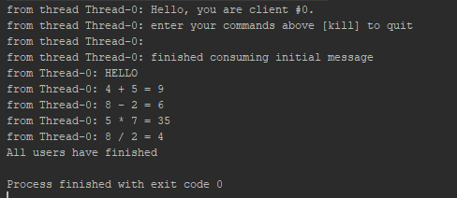

This user connects to the server and consumes the greeting message and then starts by using the capitalize command and then using each of the subsequent arithmetic commands before it sends the ‘KILL’ command server and exits

Below is the complete output from the server for this interaction

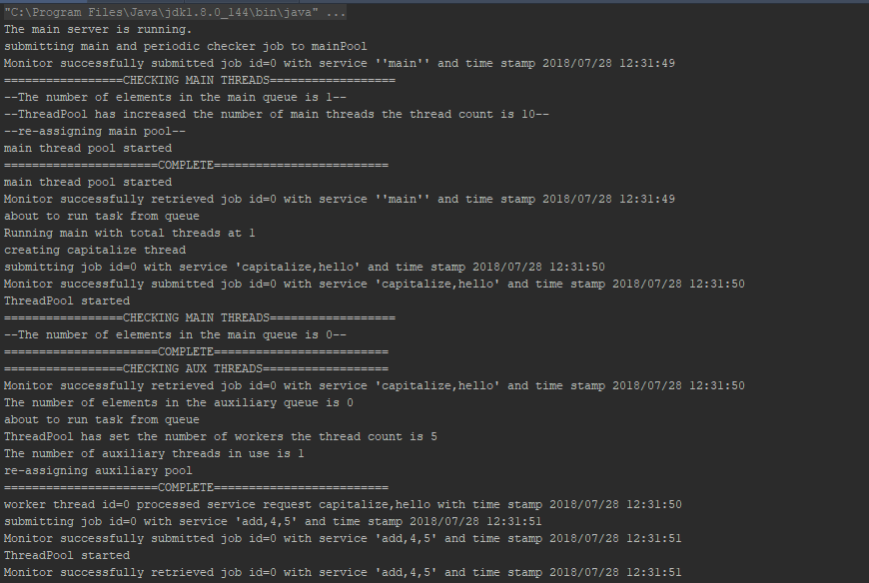

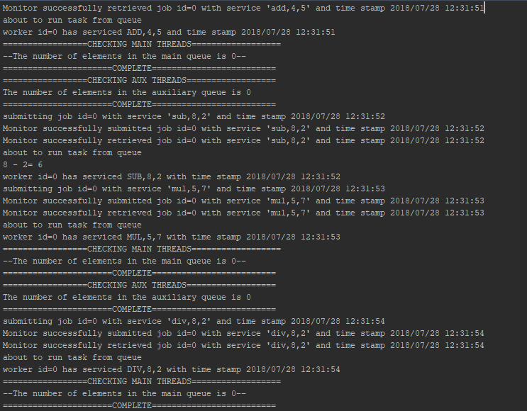

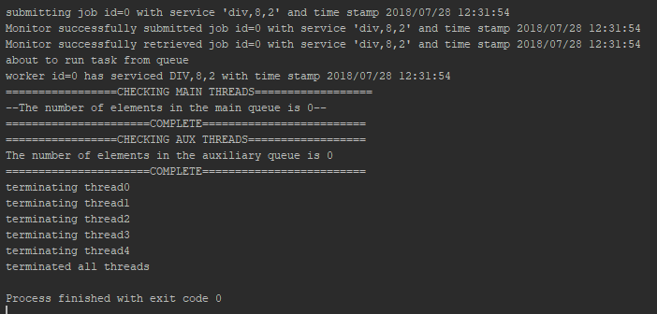

Next will be the output from a single user sending erroneous ouput

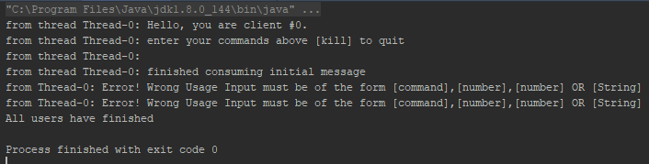

And below is the output from the server with this interaction

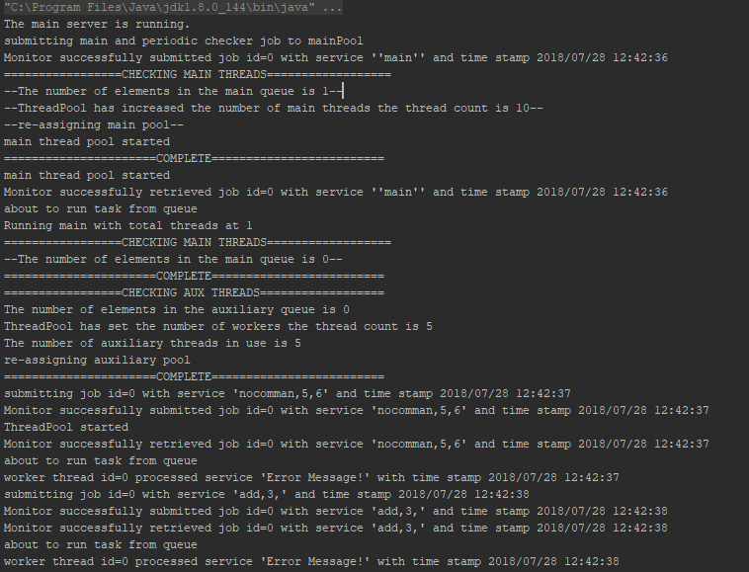

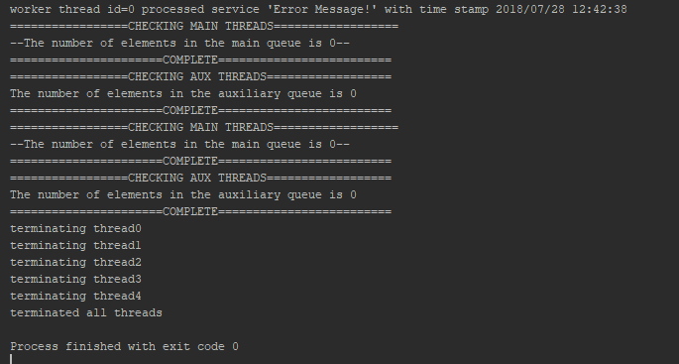

When a kill command is sent to the server the server shutdown process is as below

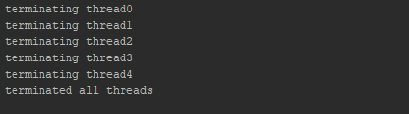

To test what happens when the server is queried by many ‘users’ at once the tester class creates 20 connections to the server and then sends a string to be capitalized. The Tester output is below

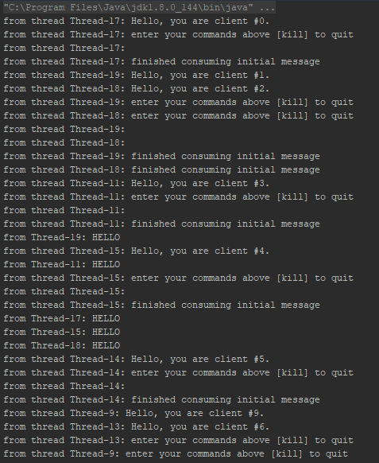

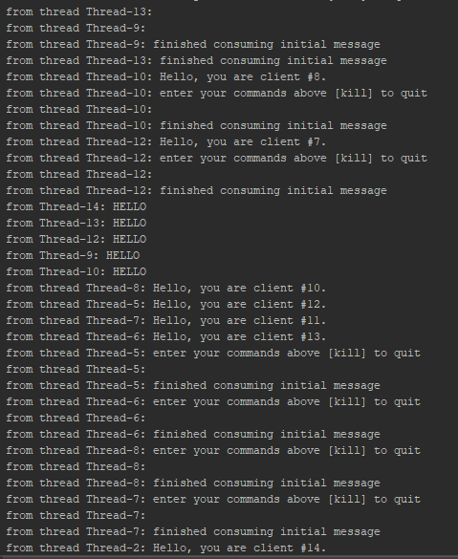

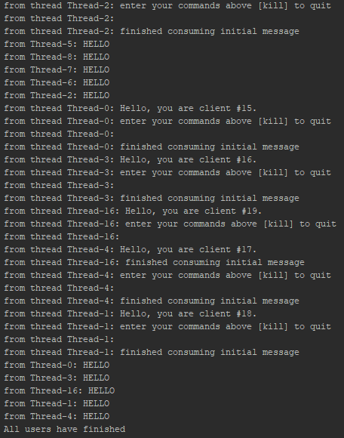

And for brevity just an instance of the server increasing the amount of threads is shown below

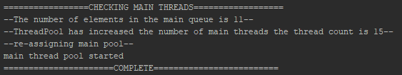

And also an instance of the server decreasing the number of threads as the queue is serviced

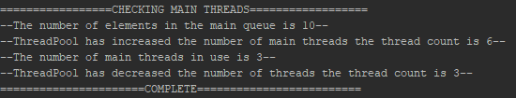

The way I designed the methods to perform these changes checks to see the number of elements in the job queue and compares that with how many threads are in actively running if that number isn’t high if the number of threads running is less than the total threads it will halve the number of threads. When the timer object checks the threads again when it sees that the thread count is less than the default of five it will reset the total number of threads back to the default.

Below is an example of the server being busy and sending back a busy server message

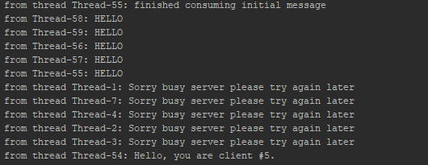

Issues:

The main issue I had when initially designing my solution was the way I was having the thread pool create threads to service the user. I had originally though that the server would have a thread to service the user’s connection and have threads for the different actions on the server i.e the users connection maintained a main thread and then any interaction was carried out on a separate thread. This was an original misunderstanding on my part and was remedied by keeping a pool of threads to service the main connections with those then having auxiliary threads if needed for execution. Both pools are monitored by the timer object that repeatedly checks the queues for size and checks how many threads are currently in use. The timer object is ultimately responsible for the shutdown of the server and the command to kill only shuts the server down if there is only no more threads actively running after the command was received.